WEEK 2
TASK6: Functional Programming using map()

6A: Shuffle the Array

PROGRAM:
class Solution {
public int[] shuffle(int[] nums, int n) {
int[] result = new int[2 * n];
int index = 0;
for (int i = 0; i < n; i++) {
result[index++] = nums[i]; // xi
result[index++] = nums[i + n]; // yi
}
return result;
}
}
OUTPUT:
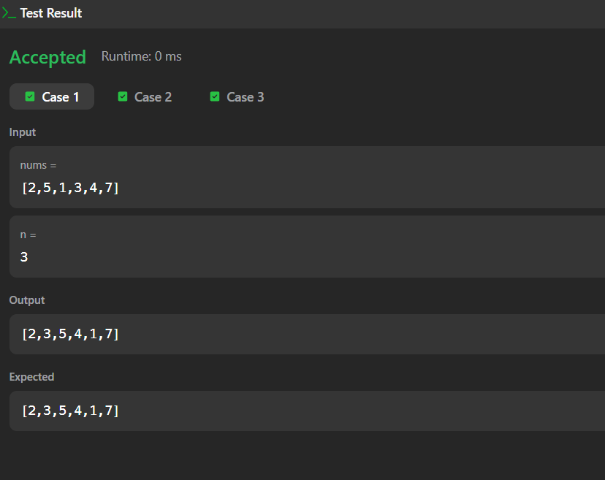
TASK 7: Functional Programming using filter()

7A: Remove Element

PROGRAM:
class Solution {
public int removeElement(int[] nums, int val) {
int k = 0;
for (int i = 0; i < nums.length; i++) {
if (nums[i] != val) {
nums[k] = nums[i];
k++;
}
}
return k;
}
}
OUTPUT:
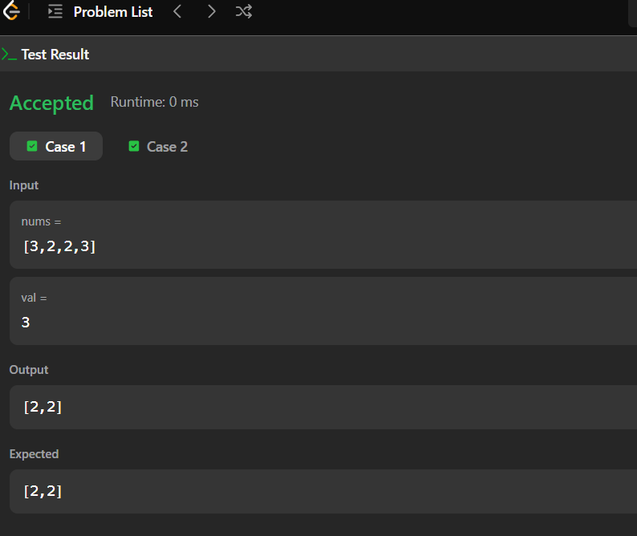
7B: Remove Duplicates from Sorted Array

PROGRAM:
class Solution {
public int removeElement(int[] nums, int val) {
int k = 0;
for (int i = 0; i < nums.length; i++) {
if (nums[i] != val) {
nums[k] = nums[i];
k++;
}
}
return k;
}
}

OUTPUT:
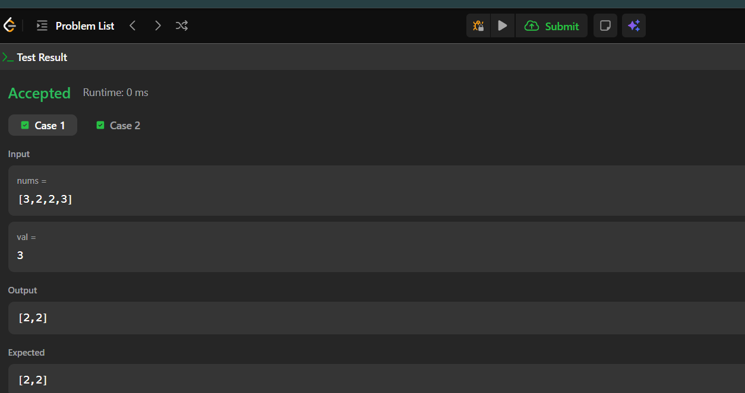
TASK 8: Functional Programming using reduce()

8A: Maximum Subarray

PROGRAM:
class Solution {
public int maxSubArray(int[] nums) {
int currentSum = nums[0];
int maxSum = nums[0];
for (int i = 1; i < nums.length; i++) {
currentSum = Math.max(nums[i], currentSum + nums[i]);
maxSum = Math.max(maxSum, currentSum);
}
return maxSum;
}
OUTPUT:
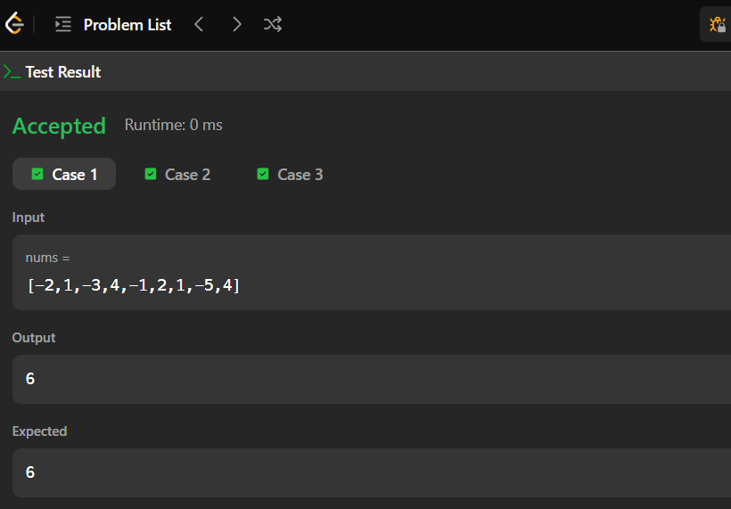
8B: Find the Highest Altitude

PROGRAM:
class Solution {
public int largestAltitude(int[] gain) {
int altitude = 0;
int max = 0;
for (int i = 0; i < gain.length; i++) {
altitude += gain[i];
max = Math.max(max, altitude);
}
return max;
}
}
OUTPUT:
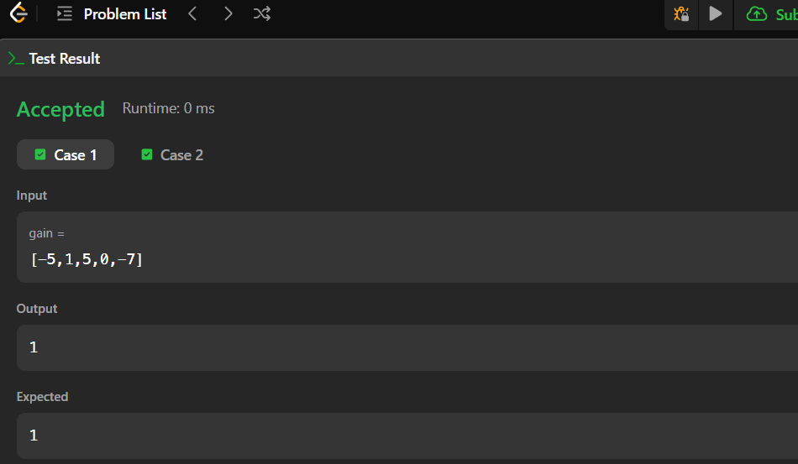
TASK9: Stream & Pipeline Processing

9A: Group Anagrams

PROGRAM:
import java.util.*;
class Solution {
public List<List<String>> groupAnagrams(String[] strs) {
HashMap<String, List<String>> map = new HashMap<>();
for (String str : strs) {
char[] chars = str.toCharArray();
Arrays.sort(chars);
String key = new String(chars);
if (!map.containsKey(key)) {
map.put(key, new ArrayList<>());
}
map.get(key).add(str);
}
return new ArrayList<>(map.values());
}
}
OUTPUT:
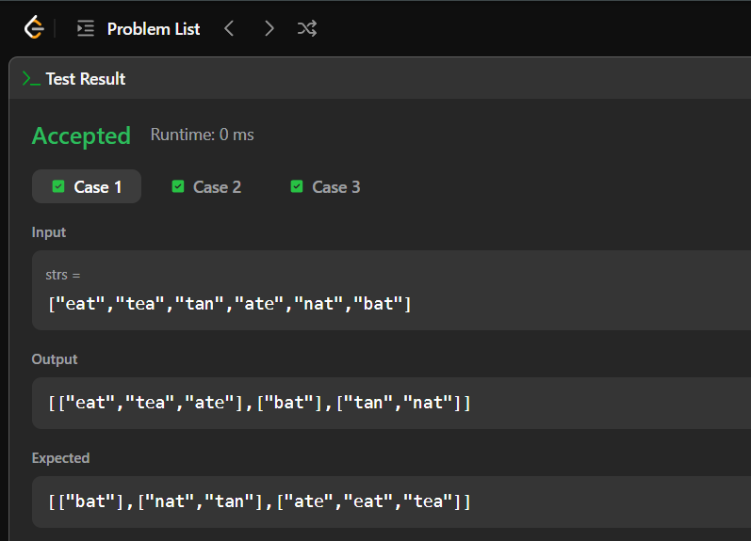
9B: Top K Frequent Elements

PROGRAM:
import java.util.*;
class Solution {
public int[] topKFrequent(int[] nums, int k) {
HashMap<Integer, Integer> map = new HashMap<>()
for (int num : nums) {
map.put(num, map.getOrDefault(num, 0) + 1);}
PriorityQueue<Integer> pq = new PriorityQueue<>(
(a, b) -> map.get(a) - map.get(b)
);
for (int num : map.keySet()) {
pq.add(num);
if (pq.size() > k) {
pq.poll();
}}
int[] result = new int[k];
for (int i = 0; i < k; i++) {
result[i] = pq.poll();
}
return result;
}
}
OUTPUT:
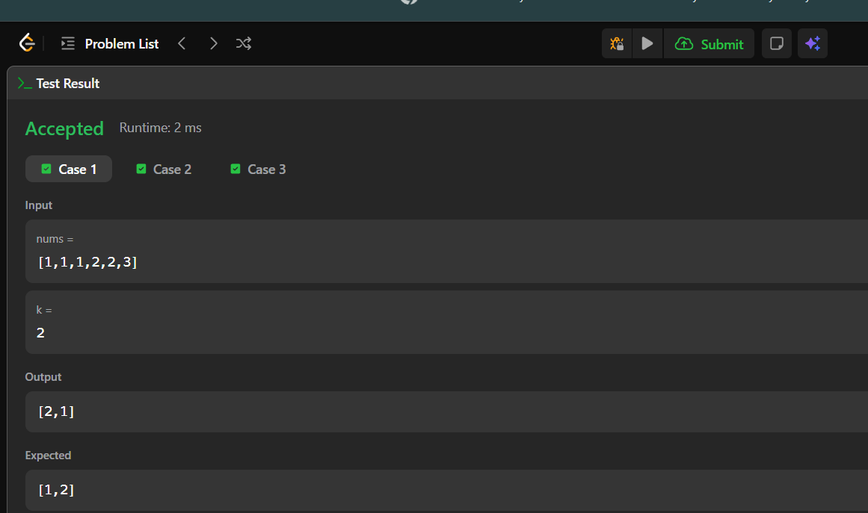

TASK 10: Stream API & Collection Processing

10A: Java Dequeue

PROGRAM:
class MyCircularDeque {
private int[] deque;
private int front;
private int rear;
private int size;
private int capacity;
public MyCircularDeque(int k) {
capacity = k;
deque = new int[k];
front = 0;
rear = k - 1;
size = 0;
}
public boolean insertFront(int value) {
if (isFull()) {
return false;
}
front = (front - 1 + capacity) % capacity;
deque[front] = value;
size++;
return true;
}
public boolean insertLast(int value) {
if (isFull()) {
return false;
}
rear = (rear + 1) % capacity;
deque[rear] = value;
size++;
return true;
}
public boolean deleteFront() {
if (isEmpty()) {
return false;
}
front = (front + 1) % capacity;
size--;
return true;
}
public boolean deleteLast() {
if (isEmpty()) {
return false;
}
rear = (rear - 1 + capacity) % capacity;
size--;
return true;
}
public int getFront() {
if (isEmpty()) {
return -1;
}
return deque[front];
}
public int getRear() {
if (isEmpty()) {
return -1;
}
return deque[rear];
}
public boolean isEmpty() {
return size == 0;
}
public boolean isFull() {
return size == capacity;
}
}
OUTPUT:
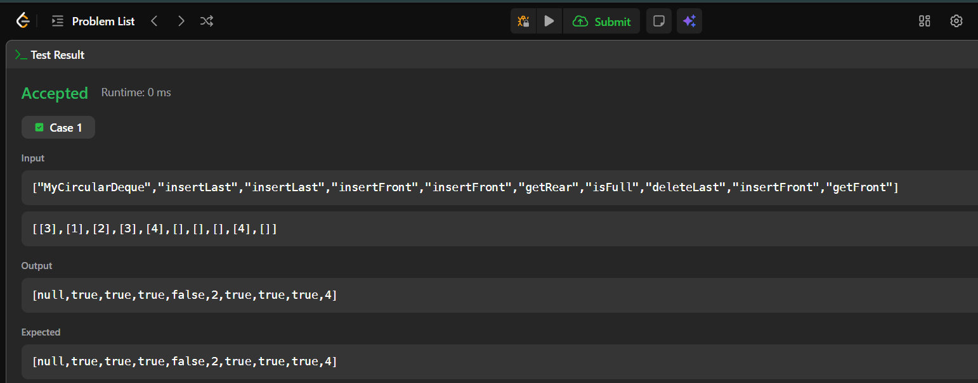
10B: Java Hashset

PROGRAM:
class MyHashSet {
boolean[] set;
public MyHashSet() {
set = new boolean[1000001];
}
public void add(int key) {
set[key] = true;
}
public void remove(int key) {
set[key] = false;
}
public boolean contains(int key) {
return set[key];
}
}
OUTPUT:
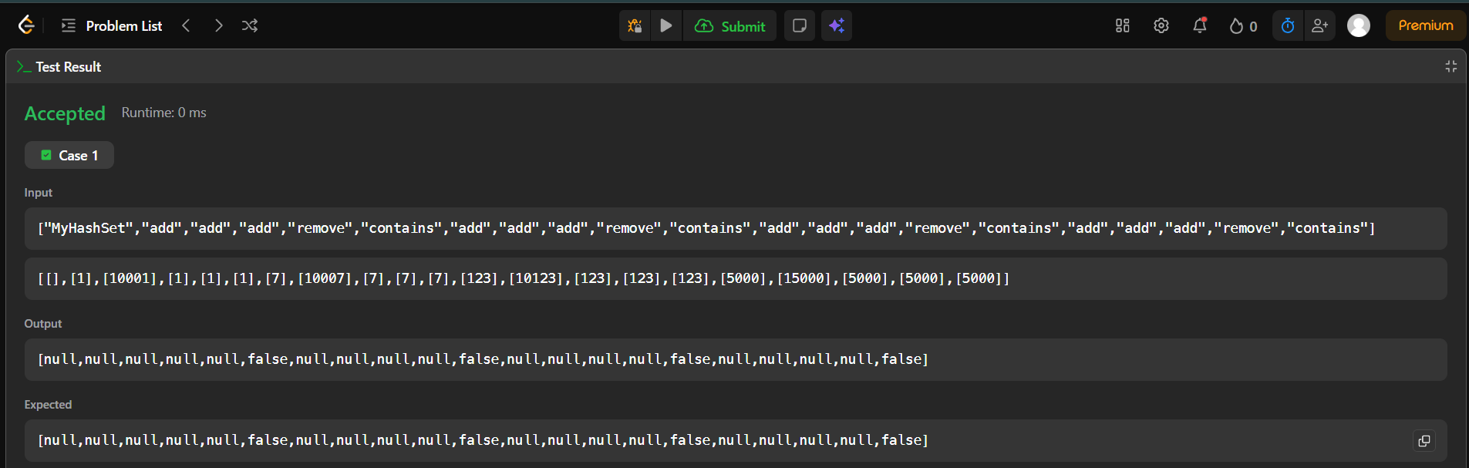

RESULT:
The week 2 is executed successfully and verified.

